OA 3.50 Server Embedded NIC and G8 BLOM display

  - Disclaimer
This spec is only interested in rendering data in the CLI and the GUI. No backend change or SOAP change is required. Xmldata will not be altered.
  - Overview
With the introduction of FlexNICs, the OA has presented the server LOM from two different viewpoints: 1) iLO/RBSU/OS, where NICs are numbered 1 – N, and 2) VC, where the FlexNICs are labeled in a completely different manner. Customers who wished to correlate the iLO data with the VC data had to manually correlate the Ethernet and Fibre addresses in order to resolve some basic port mapping issues. This spec will describe how the OA’s CLI and GUI can correlate these two different data sets and present them in a concise way to the customer.
  - Data Available
Both CLI and GUI will only need to data from the hpoa:bladeInfo and hpoa:bladeMezzInfoEx data structures.
hpoa:bladeInfo will contain a list of NICs like this:
<hpoa:numberOfNics>11</hpoa:numberOfNics>
<hpoa:nics>
<hpoa:bladeNicInfo>
<hpoa:port>NIC 1</hpoa:port>
<hpoa:macAddress>00:17:A4:77:2C:32</hpoa:macAddress>
</hpoa:bladeNicInfo>
hpoa:bladeMezzInfoEx will also contain the Flex NICs
<hpoa:mezzInfo>
<hpoa:mezzNumber>13</hpoa:mezzNumber>
<hpoa:port>
<hpoa:portNumber>1</hpoa:portNumber>
<hpoa:guid>
<hpoa:type>E</hpoa:type>
<hpoa:physicalFunction>a</hpoa:physicalFunction>
<hpoa:guid>00:17:A4:77:2C:32</hpoa:guid>
</hpoa:guid>
You can see from this example that NIC 1’s mac address is the same value as Mezz 13 Port 1 Function a’s guid value. Because they match, “NIC 1” can now be substituted for “LOM” in the CLI/GUI description.
  - Phantom iSCSI devices
ILO has a known issue of creating extra iSCSI NICs when such NICs do not in fact exist. This is an issue for the OA because the same mac address will appear for a “NIC” port as well as for an “iSCSI” port.
When the CLI or GUI is presented with the choice between two possible labels, then the guid type must be considered. For instance, if the guid type is ‘E’ or ‘C’, then a “NIC x” label is preferred. If the guid type is ‘I’ or ‘H’, then an “iSCSI x” label is preferred.
Type should only be considered when the mac address appears twice in the bladeInfo’s output.
  - G8 / Gen 8 BLOMs
Jay Brinkmeyer originally designed the new G8 BLOMs to display much like a mezzanine card. For the CLI, this meant the “FLB Adapters” were displayed after the Mezzanine cards. In the GUI, they were displayed in the Mezzanine Card Information table.
However, both ILO and VC treat these BLOMs as embedded NICs in their GUIs. It was therefore decided that the OA should also treat these as Embedded LOMs for display purposes. Therefore, the CLI will display the BLOMs before the Mezzanine cards and the GUI will display the BLOMs in the Server NIC Information table instead of the Mezzanine Cards Information table.
  - Other Gotchas
This data correlation is only possible when the ILO SMBIOS data is present and correct. The OA behavior is to only fetch these values after the server has completed POST. OA 3.50 currently does not fetch ILO SMBIOS data if the server had already completed POST when the OA comes up.
Also, at the time of this writing, a couple of G8 BLOMs have outstanding QuIX’s regarding their MAC addresses in Flex mode.
  - Unresolved Items
- Does the VC show fibre NICs as “Fiber” or “Fibre”? Generally, HP mandates “Fibre”
  - Sam Lee: Change “Fiber FlexNIC” to “FCoE FlexHBA”
- Should we use “LOM” when an iLO label cannot be found for an Embedded NIC?
  - Dan Eaton - Yes
- Should OA show “FLB Adapter #” as a prefix to the BLOMs?
  - Dan Eaton - Yes
  - CLI Examples
OA 3.30 behavior:
ProLiant BL685c G7
FlexFabric Embedded Ethernet
Ethernet FlexNIC LOM:1-a - 00:17:A4:77:2C:00
iSCSI FlexNIC LOM:1-b - 00:17:A4:77:2C:30
Ethernet FlexNIC LOM:1-c - 00:17:A4:77:2C:08
Ethernet FlexNIC LOM:1-d - 00:17:A4:77:2C:10
Ethernet FlexNIC LOM:2-a - 00:17:A4:77:2C:02
iSCSI FlexNIC LOM:2-b - 18:A9:05:5D:C6:11
Ethernet FlexNIC LOM:2-c - 00:17:A4:77:2C:0A
Ethernet FlexNIC LOM:2-d - 00:17:A4:77:2C:12
Ethernet FlexNIC LOM:3-a - 00:17:A4:77:2C:04
Ethernet FlexNIC LOM:3-b - 00:17:A4:77:2C:0C
Ethernet FlexNIC LOM:3-c - 00:17:A4:77:2C:14
Ethernet FlexNIC LOM:3-d - 00:17:A4:77:2C:18
Ethernet FlexNIC LOM:4-a - 00:17:A4:77:2C:06
Ethernet FlexNIC LOM:4-b - 00:17:A4:77:2C:0E
Ethernet FlexNIC LOM:4-c - 00:17:A4:77:2C:16
Ethernet FlexNIC LOM:4-d - 00:17:A4:77:2C:1A

Product Name: HP ProLiant BL460c Gen8

<mezzanine options>

FLB Adapter 1: HP NC555b 10GbE 2-port FlexFabric Adapter
Ethernet FlexNIC:1-a - 00:17:A4:77:2C:20
Ethernet FlexNIC:1-b - 00:17:A4:77:2C:24
Ethernet FlexNIC:1-c - 00:17:A4:77:2C:28
Ethernet FlexNIC:1-d - 00:17:A4:77:2C:2C
Ethernet FlexNIC:2-a - 00:17:A4:77:2C:22
Ethernet FlexNIC:2-b - 00:17:A4:77:2C:26
Ethernet FlexNIC:2-c - 00:17:A4:77:2C:2A
Ethernet FlexNIC:2-d - 00:17:A4:77:2C:2E

Product Name: ProLiant BL685c Gen8

NIC 1 MAC Address: D4:85:64:46:FF:A8
NIC 2 MAC Address: D4:85:64:46:FF:AC
iSCSI 1 MAC Address: 00:00:3A:20:20:20
iSCSI 2 MAC Address: 20:20:00:00:00:00

FLB Adapter 2: HP NC555b 10GbE 2-port FlexFabric Adapter
Ethernet MAC Port 1-a: D4:85:64:46:FF:A8
iSCSI/FCoE MAC Port 1-b: D4:85:64:46:FF:A9
FCoE WWN Port 1-b: 10:00:D4:85:64:46:FF:A9
Ethernet MAC Port 2-a: D4:85:64:46:FF:AC
iSCSI/FCoE MAC Port 2-b: D4:85:64:46:FF:AD
FCoE WWN Port 2-b: 10:00:D4:85:64:46:FF:AD

This server does not contain any mezzanine cards

OA 3.50 behavior:
ProLiant BL685c G7
FlexFabric Embedded Ethernet
Ethernet FlexNIC (NIC 1) LOM:1-a 00:17:A4:77:2C:00
iSCSI FlexNIC (iSCSI 1) LOM:1-b 00:17:A4:77:2C:30
Ethernet FlexNIC (NIC 5) LOM:1-c 00:17:A4:77:2C:08
Ethernet FlexNIC (NIC 7) LOM:1-d 00:17:A4:77:2C:10
Ethernet FlexNIC (NIC 2) LOM:2-a 00:17:A4:77:2C:02
iSCSI FlexNIC (iSCSI 2) LOM:2-b 18:A9:05:5D:C6:11
Ethernet FlexNIC (NIC 6) LOM:2-c 00:17:A4:77:2C:0A
Ethernet FlexNIC (NIC 8) LOM:2-d 00:17:A4:77:2C:12
Ethernet FlexNIC (NIC 9) LOM:3-a 00:17:A4:77:2C:04
Ethernet FlexNIC (NIC 11) LOM:3-b 00:17:A4:77:2C:0C
Ethernet FlexNIC (NIC 13) LOM:3-c 00:17:A4:77:2C:14
Ethernet FlexNIC (NIC 15) LOM:3-d 00:17:A4:77:2C:18
Ethernet FlexNIC (NIC 10) LOM:4-a 00:17:A4:77:2C:06
Ethernet FlexNIC (NIC 12) LOM:4-b 00:17:A4:77:2C:0E
Ethernet FlexNIC (NIC 14) LOM:4-c 00:17:A4:77:2C:16
Ethernet FlexNIC LOM:4-d 00:17:A4:77:2C:1A

Product Name: HP ProLiant BL460c Gen8
FLB Adapter 1: HP NC555b 10GbE 2-port FlexFabric Adapter
Ethernet FlexNIC LOM1:1-a 00:17:A4:77:2C:20
Ethernet FlexNIC LOM1:1-b 00:17:A4:77:2C:24
Ethernet FlexNIC LOM1:1-c 00:17:A4:77:2C:28
Ethernet FlexNIC LOM1:1-d 00:17:A4:77:2C:2C
Ethernet FlexNIC LOM1:2-a 00:17:A4:77:2C:22
Ethernet FlexNIC LOM1:2-b 00:17:A4:77:2C:26
Ethernet FlexNIC LOM1:2-c 00:17:A4:77:2C:2A
Ethernet FlexNIC LOM1:2-d 00:17:A4:77:2C:2E

<mezzanine options>

Product Name: ProLiant BL685c Gen8

FLB Adapter 2: HP NC555b 10GbE 2-port FlexFabric Adapter
Ethernet (NIC 1) LOM2:1-a D4:85:64:46:FF:A8
iSCSI LOM2:1-b D4:85:64:46:FF:A9
FCoE HBA LOM2:1-b 10:00:D4:85:64:46:FF:A9
Ethernet (NIC 2) LOM:2-a D4:85:64:46:FF:AC
iSCSI LOM2:2-b D4:85:64:46:FF:AD
FCoE HBA LOM2:2-b 10:00:D4:85:64:46:FF:AD

This server does not contain any mezzanine cards

  - GUI Examples
OA 3.50 Server Nic Information
- Enhancement Recommended: Add LOM/FLB name(s) to match CLI.
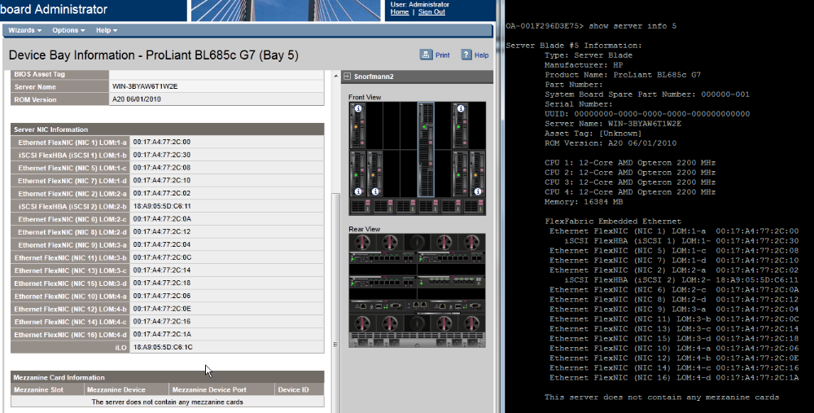
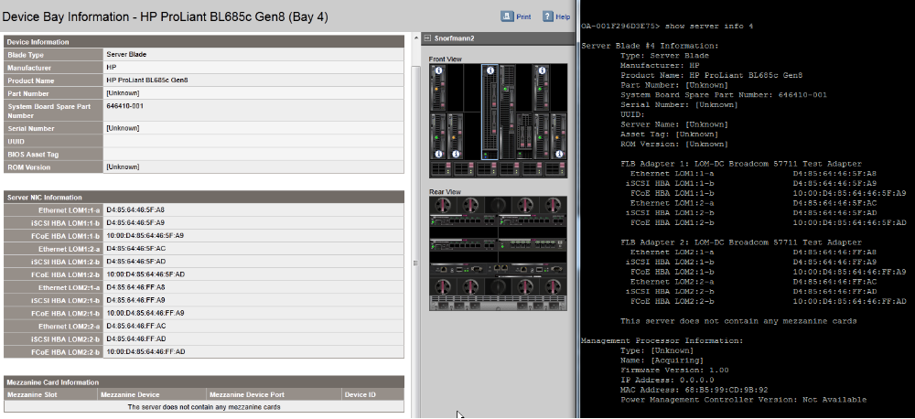
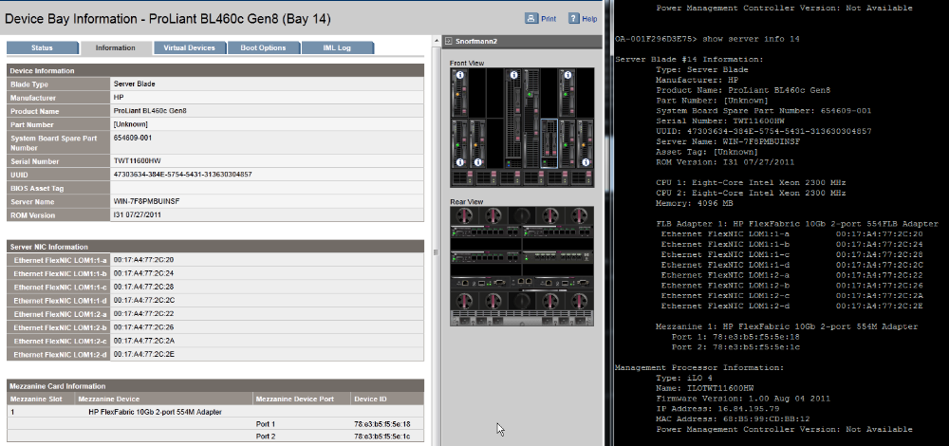

OA 3.50 Port Mapping Table View
- Enhancement Recommended: List BLOMs before mezzanine cards in all device bay views.
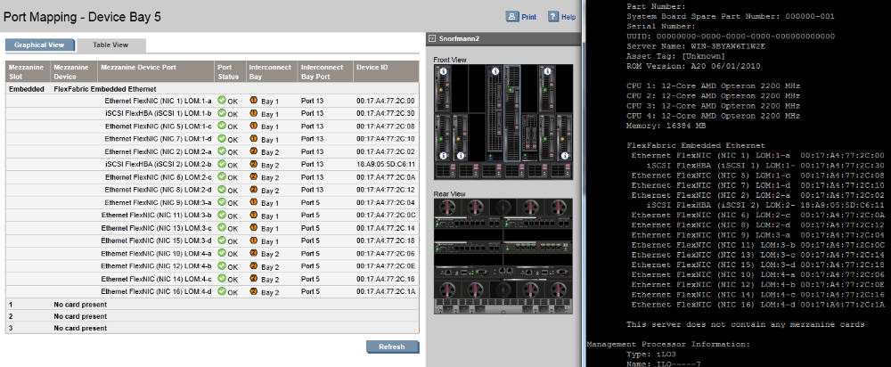
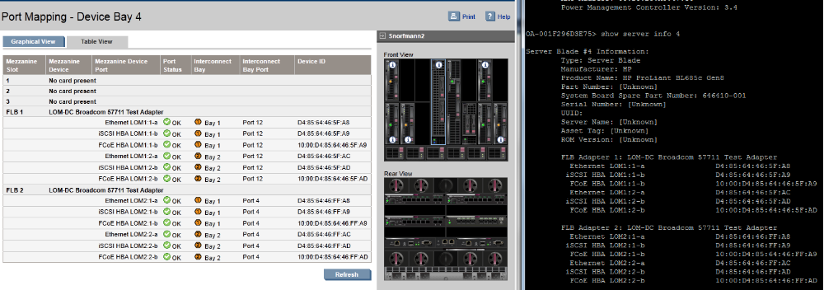
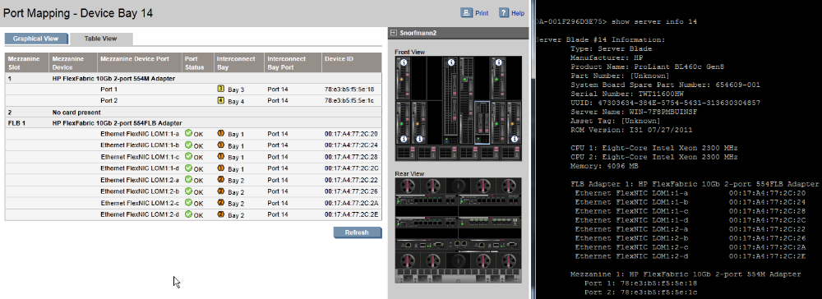

OA 3.50 Interconnect Port Mapping
